Project Design phase-1 Solution Architecture

Date | 21 October 2022
Team ID | PNT2022TMID10090
Project Name | Intelligent Vehicle Damage Assessment and Cost Estimator for Insurance Companies
Maximum Marks | 4

Solution Architecture Diagram:

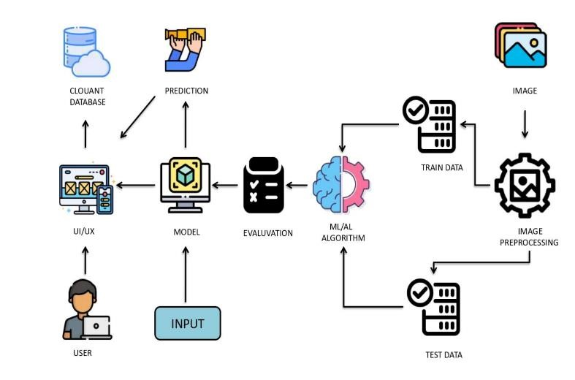

Technologies used for Intelligent Vehicle Damage Assessment and Cost Estimator for Insurance Companies:
- Working with Image processing technique
- Working in Trained CNN model
- Working in Deep Learning
- Using Python Programming
- Build web application using Python Flask

Platform
- Git & GitHub - Project Management
- IBM Cloud - Hosting
- IBM Watson - Training the Deep Learning Model

